03.05.2020



**MIDDLE EAST TECHNICAL UNIVERSITY**

DEPARTMENT OF ELECTRICAL AND ELECTRONICS ENGINEERING

**EE 568** Project #3

***PM Motor Comparison Analysis***

GÖKHAN ÇAKAL – **2332120**

# Introduction

In this report, the electric machine winding design and analysis are studied. In electrical machines, windings play an essential role because they define the critical machine performance indicators such as current density, fill factor or winding factor, etc. In the winding design, the number of slots per pole per phase determines the winding type. There are two types of winding designs, integral slot winding, and fractional slot winding. If the number of slots per pole per phase is an integer, the winding is integral slot winding. In the first question of the report, integral slot winding design is conducted, and it is analyzed. The main parameter that defines a winding is winding factor, and it defines how much of the available voltage can be induced. It is determined by distribution and pitch factors. Integral slot winding design is analyzed by calculating these winding factors. Also, each harmonic has a different winding factor and in the analysis, the winding factor for the third and fifth harmonics are considered. In the second question, the fractional slot windings are studied, where the number of slots per pole per phase is fractional. In the design, the winding diagram is obtained for 20-pole 30 slots and 20-pole 24-slots machines. Their winding factors are compared with their harmonics. The comparison study is conducted. The report is ended with the third question, where the winding analysis of 20-pole 24-slots machine is verified with computer tools. I the analysis, RMXprt tool of Ansys Maxwell is preferred. The obtained results are compared with analytical results and the report is concluded.

# Question I: Magnetic Loading

## Electrical equivalent circuit

In this part, the stator is assumed to be solid cylinder for 4-pole surface-mount PM machine. In the machine, NdFeB magnets are used with N42 grade, which has remanence flux density of 1.315 T. The machine is shown in Figure 1.

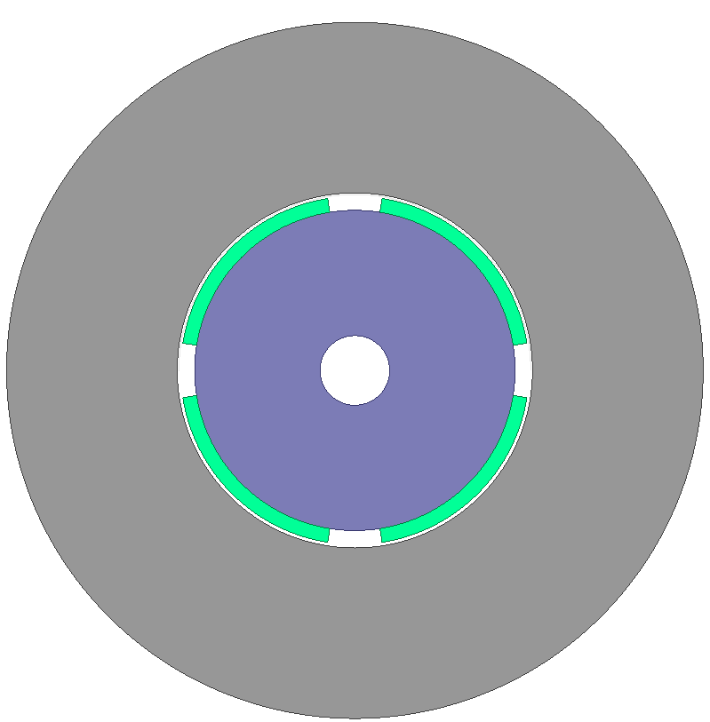

Figure 1: Analyzed machine

The magnetic equivalent circuit of a magnet can be shown as in Figure 2.

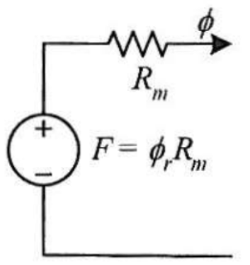

Figure 2: Electrical modeling of a magnet

$$R_{m}=\frac{l_{m}}{μ_{0}μ_{r}A_{m}}$$

$$ϕ_{r}=B_{r}A_{m}$$

Then, the electrical equivalent of a pole pair can be found easily. Air gap is also modeled as a series added resistance. In this analysis, the cores are assumed to be infinitely permeable, where there is no MMF drop. Then, the electrical circuit model of the machine under one pole can be seen as in Figure 3.



Figure 3: Electrical equivalent of the machine under one pole pair

The analytical calculation of air gap flux density starts with derivation of air gap flux. In the analysis, it is assumed that there is no fringing and leakage flux and air gap flux density has square shape. Then, air gap flux can be derived using electrical equivalent circuit as follows:

$$ϕ_{m}=ϕ_{g}=\frac{2ϕ_{r}R_{m}}{2\left(R_{m}+R_{g}\right)}=\frac{ϕ_{r}R_{m}}{R_{m}+R_{g}}$$

$$ϕ_{r}=B_{r}A_{m}$$

$$R_{m}=\frac{l_{m}}{μ_{0}μ_{r}A_{m}}$$

$$R_{g}=\frac{l_{g}}{ϕ_{0}A_{g}}$$

$$A_{m}=A_{g}$$

$l_{m}=4 mm$ and $l_{g}=1 mm$

$$ϕ_{g}=A_{m}*1.315*\frac{\frac{4}{1.05}}{\frac{4}{1.05}+1}=1.04 A_{m}$$

$$B_{g}=\frac{ϕ_{g}}{A_{g}}=\frac{ϕ_{g}}{A_{m}}=1.04 T$$

It is found that air gap peak flux density is 1.04 T, analytically. Magnetic field intensity of the magnet can be found as follows

$$B_{m}=B_{r}+μ_{0}μ_{r}H_{m}$$

$$H_{m}=\frac{B_{m}-B_{r}}{μ_{0}μ_{r}}=-207.2 kA/m$$

Then, the BH characteristics of the magnet and its operation point can be shown as in Figure 4.



Figure 4: Operation point of the magnet on BH characteristics

## Magnetic loading

Magnetic loading is defined as average of fundamental component of the air gap flux density. It is assumed in our analysis that air gap flux density has square shaped waveform. Its peak of fundamental component can be found as

$$B_{p1}=B_{square}\frac{4}{π}\sin\left(\frac{θ_{m}}{2}\right)$$

$$B_{p1}=1.04\frac{4}{π}\sin\left(90*0.8\right)=1.26 T$$

$$B_{avg}=B_{p1}*\frac{2}{π}=1.26*\frac{2}{π}=0.8 T$$

## FEA results

Using ANSYS Maxwell, the model shown in Figure 1 is solved. The results are shown in Figure 5.

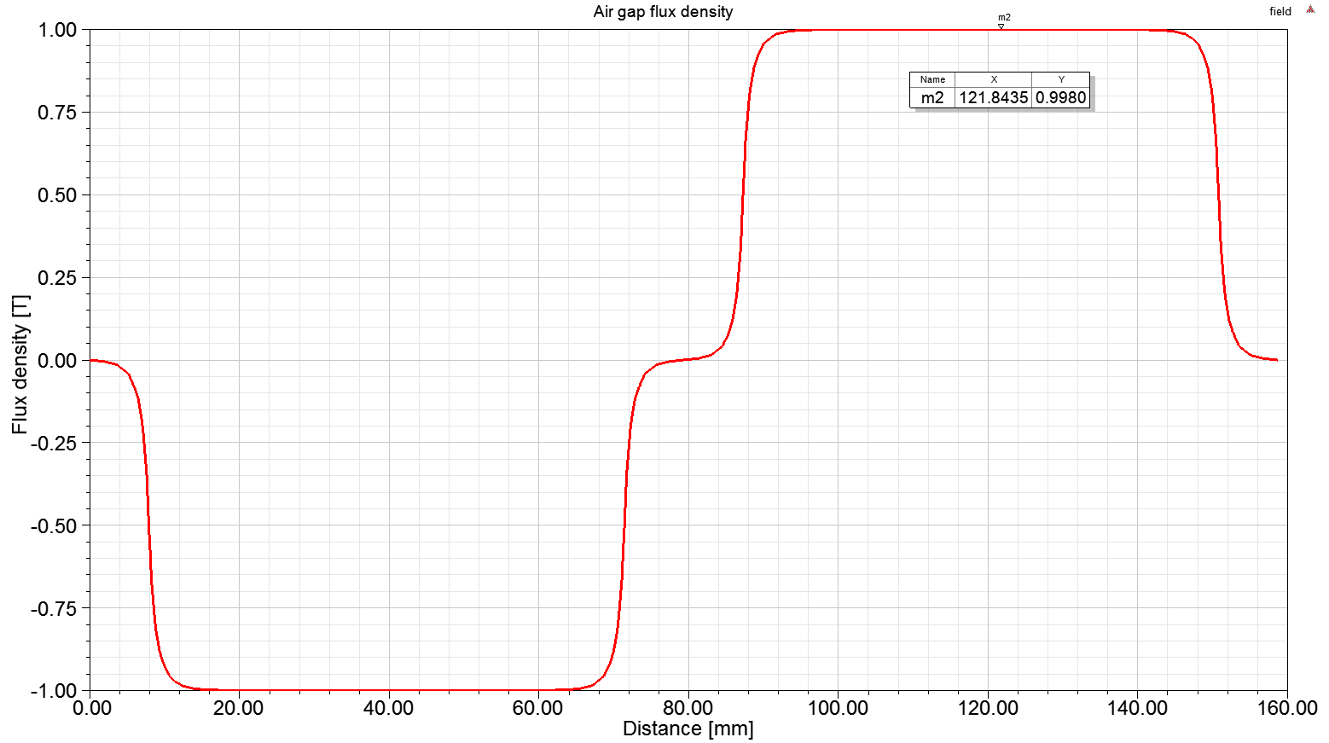

Figure 5: Air gap flux density over one pole-pair

The results obtained using FEA shows that peak flux density is around 1 T. In our analysis, it was 1.04 T. Therefore, there is less than 5% difference, which is mainly caused by the assumption that there is no leakage and fringing effect and there is no saturation in the cores. In overall, the obtained results are in good agreement with analytical calculations.

# Question II: Electrical Loading & Machine Sizing

## Slot number selection

We have four pole machine. Let’s assume integral slot winding with number of slots per pole per phase is two. Then, the number of slots is

$$Q_{s}=q*phase*pole=2*3*4$$

$$Q_{s}=24 slots$$

## Wire selection

Phase current is 2.5 Arms. With maximum current density of 5 A/mm2, the minimum wire cross sectional area can be found as

$$A_{min}=\frac{I}{J_{max}}=\frac{2.5}{5}=0.5 mm^{2}$$

Using AWG standards, it is found that AWG20 wire has closest value of cross sectional area. Therefore, AWG20 wire is selected with

$$A_{wire}=0.519 mm^{2}$$

## Slot design back core thickness selection

We can proceed by selecting a slot radio, which is defined as

$$d=\frac{slot inner diameter}{slot outer diamer}$$

Using rule of thumbs defined in the lecture, let’s pick slot ratio of 0.7. Then, the slot inner diameter can be calculated as

$$0.7=\frac{102 mm}{OD}$$

$$OD=145.7 mm$$

$slot height=21.8 mm$

In the design, parallel teeth option is preferred. With this selection, the slot area is calculated by drawing the actual stator model as in Figure 6.



Figure 6: Slot area of the design

It is observed that the slot area is 193 mm2. Then, assuming that the maximum fill factor is 0.6, the maximum number of turns can be calculated as

$$ff_{max}=\frac{N_{slotmax}*A_{wire}}{A_{slot}}$$

$$N_{slotmax}=\frac{0.6*193}{0.516}=224 turns$$

Let’s choose the number of turns per slot as 200 turns. With this selection, fill factor is

$$ff=\frac{0.516*200}{193}=0.53$$

The back core thickness can be calculated as follows

$$\frac{B_{avg}*A_{pole}}{2}=B_{core}*A_{core}$$

$$h_{core}=\frac{B_{avg}πD_{airgap}}{2 pole B_{coremax}}=\frac{0.8*π*0.101}{2*4*1}=32 mm$$

## Electrical loading

The electrical loading is calculated as follows

$$A=\frac{N_{slot}I_{wire}Q_{s}}{πD_{airgap}}=\frac{200*2.5A*24}{π*0.101}=37.8\frac{kA}{m}$$

For PMSM, as a rule of thumb, the electrical loading should be between 35-65 kA/m. Our calculation is coherent with this values.

## Average tangential stress and torque

The average tangential stress is calculated as follows

$$σ=\frac{AB_{p1}\cos{θ}}{\sqrt{2}}=\frac{37.8*1.26T*1}{\sqrt{2}}=33.7 kPa$$

The torque of the machine is calculated by tangential stress and surface area as follows

$$T=σπD_{airgap}l_{ax}r_{airgap}=33.7kPa*π*0.101mm*0.1m*\frac{0.101}{2}=54 Nm$$

## Power calculation

$$P=T*ω=54*1500*\frac{π}{30}=8.5 kW$$

# Question III: Comparison & Optimization

## Slot ratio optimization

First, let’s derive the slot ratio at which the torque is maximum. Note that we have parallel teeth design. In that case, the slot area is proportional with slot ratio defined as follows

$$d=\frac{ID_{slot}}{OD_{slot}}$$

$$Slot area→ \left(1-d^{2}\right)$$

$$A→\frac{1-d^{2}}{d}$$

$$σ→\frac{1-d^{2}}{d}$$

$$Torque→\left(1-d^{2}\right)d$$

Taking the derivative and equating to the zero, the slot ratio that gives maximum torque can be found as follows

$$d=0.58$$

Now, let’s try to find rotor diameter. In our case, the outer diameter is fixed to 160 mm. As we found before, the back core thickness is a function of air gap diameter as follows

$$h_{core}=\frac{B_{avg}πD_{airgap}}{2 pole B_{coremax}}$$

$$ID_{slot}=D_{airgap}+1mm=0.58*OD_{slot}$$

$$h_{slot}=\frac{OD_{slot}-ID_{slot}}{2}=0.21 OD_{slot}$$

Solving these three equations together yields in

$$OD_{slot}=117.7 mm$$

$$ID_{slot}=68.3 mm$$

$$D_{airgap}=67.3 mm$$

$$h_{slot}=24.7 mm$$

$$h_{core}=21.1 mm$$

Then, we can find rotor diameter as

$$D_{rotor}=D_{airgap}-1mm$$

$$D_{rotor}=66.3 mm$$

Now, let’s calculate the tangential stress and torque values. Let’s start with number of conductors in a slot.

$$A_{slot}=175 mm^{2}$$

$$N_{slotmax}=\frac{0.6*175}{0.516}=203 turns$$

Let’s choose the number of conductors in a slot as 200. Then, the electrical loading is

$$A=\frac{N_{slot}I_{wire}Q_{s}}{πD_{airgap}}=\frac{200*2.5A*24}{π*67.3 mm}=56.8 \frac{kA}{m}$$

Then the average tangential stress and the torque values can be calculated as

$$σ=\frac{AB_{p1}\cos{θ}}{\sqrt{2}}=\frac{56.8*1.26T*1}{\sqrt{2}}=50.6 kPa$$

The torque of the machine is calculated by tangential stress and surface area as follows

$$T=σπD_{airgap}l_{ax}r_{airgap}=50.6 kPa*π*67.3mm*0.1m*\frac{67.3}{2}=36 Nm$$

Now, let’s try to verify our results using FEA. In ANSYS Maxwell, the same machine is constructed as shown in Figure 7.

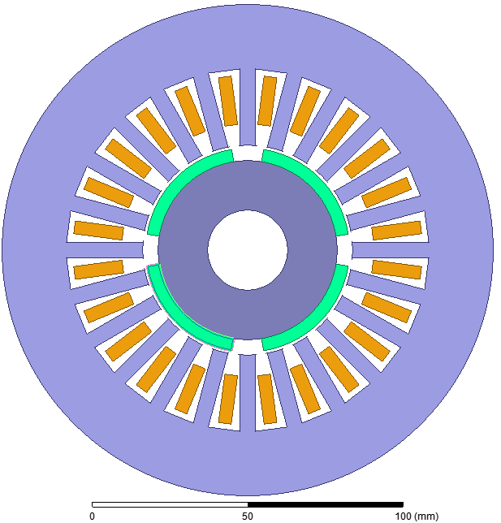

Figure 7: Optimized machine with 0.58 slot ratio

In the FEA analysis, it is found that the machine rated torque is 31 Nm. There is 13% difference between analytical torque and FEA torque. This difference is mainly caused by the ignored harmonics while defining electrical loading. The current harmonics will also contribute to the torque production and it may decrease or increase the torque rating.

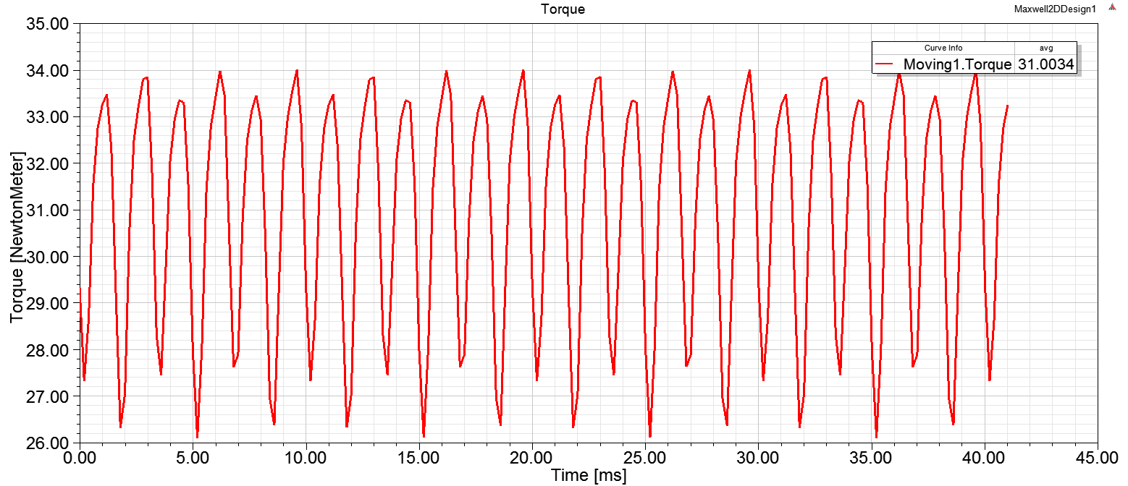

Figure 8: The torque of the machine

The comparison of the machines obtained in this part and in the previous part is tabulated in Table 1. The comparison is carried out on volumetric torque density.

Table 1: Comparison of the machines

|  |  |  |  |
| --- | --- | --- | --- |
|  | **Outer diameter** | **Torque** | **Torque density** |
| **The previous machine in QII** | 210 mm | 54 Nm | 15 607 Nm/m3 |
| **The optimized machine in QIII** | 160 mm | 36 Nm | 17 910 Nm/m3 |

It can be seen that optimizing the slot ratio increased the volumetric torque density.

## Ferrite design

In this part, we will replace NdFeB magnets with ferrite magnets with 0.4 T remanence flux density. First of all, the electrical loading is independent of magnet material and therefore, there is no change in electrical loading. The magnetic loading is directly proportional with magnet remanence flux density. Therefore, the magnetic loading changes as follows

$$B_{avg-ferrite}=B_{avg-NdFeB}*\frac{Br_{ferrite}}{Br_{NdFeB}}=0.8 T*\left(\frac{0.4}{1.315}\right)=0.24 T$$

The average tangential stress and the torque values also decrease with the same ratio. Therefore,

$$σ_{fer}=σ*\frac{0.4}{1.315}=50.6*\frac{0.4}{1.315}=15.4 kPa$$

$$T_{fer}=T*\frac{0.4}{1.315}=36*\frac{0.4}{1.315}=11 Nm$$

As a result, with the same geometry, the material change to ferrite results in 70% loss in torque value.